Complete Python Source Code

(a) – Python Code
import numpy as np import pandas as pd

data = {
"Rainfall": [450, 600, 700, 800, 950, 1100, 500, 650, 750, 900],
"Temperature": [35, 33, 32, 30, 29, 28, 36, 34, 31, 30],
"Humidity": [45, 50, 55, 60, 65, 70, 42, 48, 58, 62],
"Yield": [2.1, 2.5, 2.8, 3.0, 3.3, 3.6, 2.0, 2.4, 2.9, 3.2]
}

df = pd.DataFrame(data)

# Add missing values for demonstration df.loc[2, "Rainfall"] = np.nan df.loc[5, "Temperature"] = np.nan

# Missing-value imputation
for col in ["Rainfall", "Temperature", "Humidity", "Yield"]: df[col] = df[col].fillna(df[col].mean())

# Derived features
df["GDD"] = np.maximum(df["Temperature"] - 10, 0) df["Rainfall_Anomaly"] = df["Rainfall"] - df["Rainfall"].mean() df["Temperature_Humidity_Index"] = (
df["Temperature"] - 0.55 * (1 - df["Humidity"] / 100)
* (df["Temperature"] - 14.5)
)

print(df)
print("\\nSummary statistics:") print(df.describe())

print("\\nCorrelation:") print(df.corr(numeric_only=True))

print("\\nAverage yield by rainfall group:") df["Rainfall_Group"] = pd.cut(
df["Rainfall"], bins=[0, 600, 800, 2000], labels=["Low", "Medium", "High"]
)
print(df.groupby("Rainfall_Group", observed=True)["Yield"].mean())
Program and output:
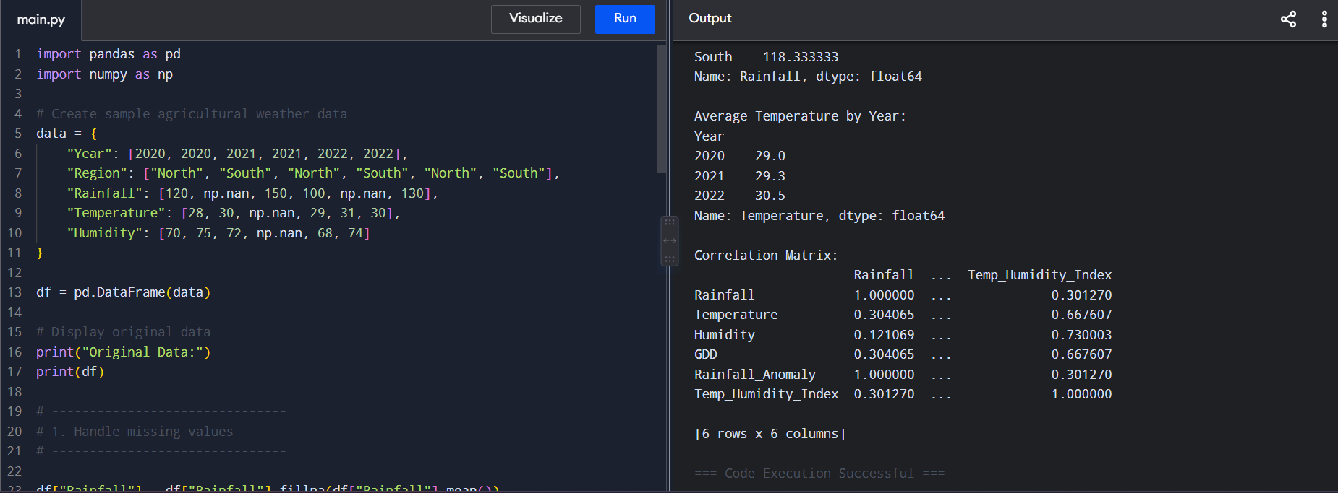

(b) – Python Code
import numpy as np import pandas as pd

data = {
"District": ["A","A","B","B","C","C","D","D","E","E","F","F"],
"Season": ["Kharif","Rabi"] * 6,
"Rainfall": [450,600,700,800,950,1100,500,650,750,900,1000,1200],
"Temperature": [35,33,32,30,29,28,36,34,31,30,29,27],
"Humidity": [45,50,55,60,65,70,42,48,58,62,68,75],
"Yield": [2.1,2.5,2.8,3.0,3.3,3.6,2.0,2.4,2.9,3.2,3.5,3.8]
}

df = pd.DataFrame(data)

features = ["Rainfall", "Temperature", "Humidity"]
X = df[features].values.astype(float) y = df["Yield"].values.astype(float)

# Min-max normalization X_min = X.min(axis=0) X_max = X.max(axis=0)
X_norm = (X - X_min) / (X_max - X_min + 1e-12)

# Manual train/validation split split = int(0.75 * len(X_norm))
X_train, X_val = X_norm[:split], X_norm[split:] y_train, y_val = y[:split], y[split:]

def euclidean(a, b):
return np.sqrt(np.sum((a - b) ** 2))

def mahalanobis(a, b, covariance): diff = a - b
inv_cov = np.linalg.pinv(covariance) return np.sqrt(diff @ inv_cov @ diff.T)
cov = np.cov(X_train, rowvar=False) + np.eye(X_train.shape[1]) * 1e-6 def knn_predict(query, X_train, y_train, k, metric="euclidean"):
distances = []

for i in range(len(X_train)): if metric == "euclidean":
d = euclidean(query, X_train[i]) else:
d = mahalanobis(query, X_train[i], cov) distances.append(d)

distances = np.array(distances) nearest = np.argsort(distances)[:k] return np.mean(y_train[nearest])

print("KNN validation:") results = []

for metric in ["euclidean", "mahalanobis"]: for k in range(1, 6):
predictions = np.array([
knn_predict(x, X_train, y_train, k, metric) for x in X_val
])
mse = np.mean((y_val - predictions) ** 2) results.append([metric, k, mse])
print(metric, "k =", k, "MSE =", round(mse, 4))

results_df = pd.DataFrame(results, columns=["Metric", "k", "MSE"]) best = results_df.loc[results_df["MSE"].idxmin()]
print("\\nBest configuration:") print(best)

# Example prediction
new_point = np.array([800, 31, 60], dtype=float) new_point = (new_point - X_min) / (X_max - X_min + 1e-12)

prediction = knn_predict(
new_point, X_norm, y, int(best["k"]), best["Metric"]
)

print("\\nPredicted yield:", round(prediction, 3))

Program and output

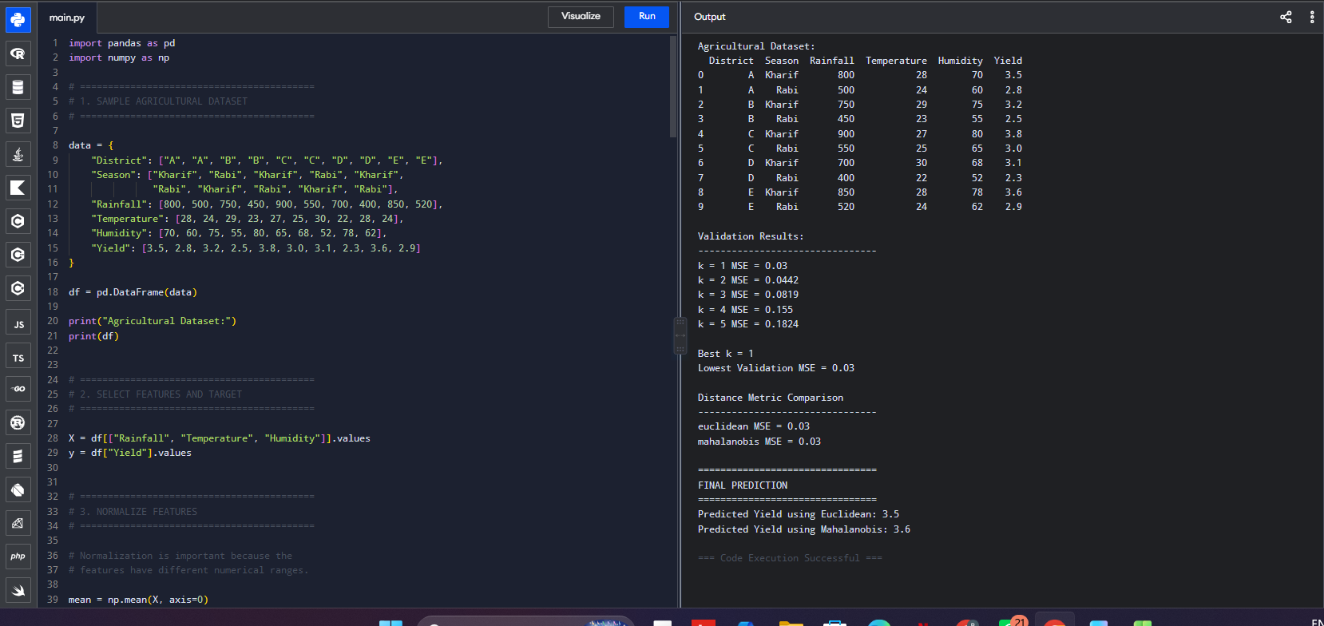

(c) – Python Code
import numpy as np import pandas as pd

data = {
"Rainfall": [450,600,700,800,950,1100,500,650,750,900,1000,1200],
"Temperature": [35,33,32,30,29,28,36,34,31,30,29,27],
"Humidity": [45,50,55,60,65,70,42,48,58,62,68,75],
"Yield": [2.1,2.5,2.8,3.0,3.3,3.6,2.0,2.4,2.9,3.2,3.5,3.8]
}

df = pd.DataFrame(data)

features = ["Rainfall", "Temperature", "Humidity"]
X = df[features].values.astype(float) y = df["Yield"].values.astype(float)

# Normalize
X_min = X.min(axis=0) X_max = X.max(axis=0)
Xn = (X - X_min) / (X_max - X_min + 1e-12)

split = int(0.75 * len(Xn))
X_train, X_val = Xn[:split], Xn[split:] y_train, y_val = y[:split], y[split:]

def lwr_predict(query, X_train, y_train, bandwidth): distances = np.sum((X_train - query) ** 2, axis=1) weights = np.exp(-distances / (2 * bandwidth ** 2))

# Add intercept
A = np.column_stack((np.ones(len(X_train)), X_train)) q = np.r_[1.0, query]

W = weights[:, None] theta = np.linalg.pinv(
A.T @ (W * A) + 1e-8 * np.eye(A.shape[1])
) @ (A.T @ (weights * y_train)) return q @ theta
bandwidths = [0.05, 0.1, 0.2, 0.5, 1.0] lwr_results = []

for h in bandwidths: pred = np.array([
lwr_predict(x, X_train, y_train, h) for x in X_val
])
mse = np.mean((y_val - pred) ** 2) lwr_results.append([h, mse]) print("Bandwidth:", h, "MSE:", round(mse, 4))

lwr_df = pd.DataFrame(lwr_results, columns=["Bandwidth", "MSE"]) best_h = lwr_df.loc[lwr_df["MSE"].idxmin(), "Bandwidth"]
print("\\nBest bandwidth:", best_h) # Manual KNN comparison
def knn_predict(query, k):
distances = np.sqrt(np.sum((X_train - query) ** 2, axis=1)) idx = np.argsort(distances)[:k]
return np.mean(y_train[idx]) knn_results = []
for k in range(1, 6):
pred = np.array([knn_predict(x, k) for x in X_val]) mse = np.mean((y_val - pred) ** 2) knn_results.append([k, mse])

knn_df = pd.DataFrame(knn_results, columns=["k", "MSE"]) best_k = knn_df.loc[knn_df["MSE"].idxmin(), "k"]

print("Best KNN k:", best_k)
print("Best KNN MSE:", knn_df["MSE"].min())
print("Best LWR MSE:", lwr_df["MSE"].min())

print("\\nBias-variance interpretation:")
print("Small k / small bandwidth -> lower bias, higher variance.") print("Large k / large bandwidth -> higher bias, lower variance.")

Program and output

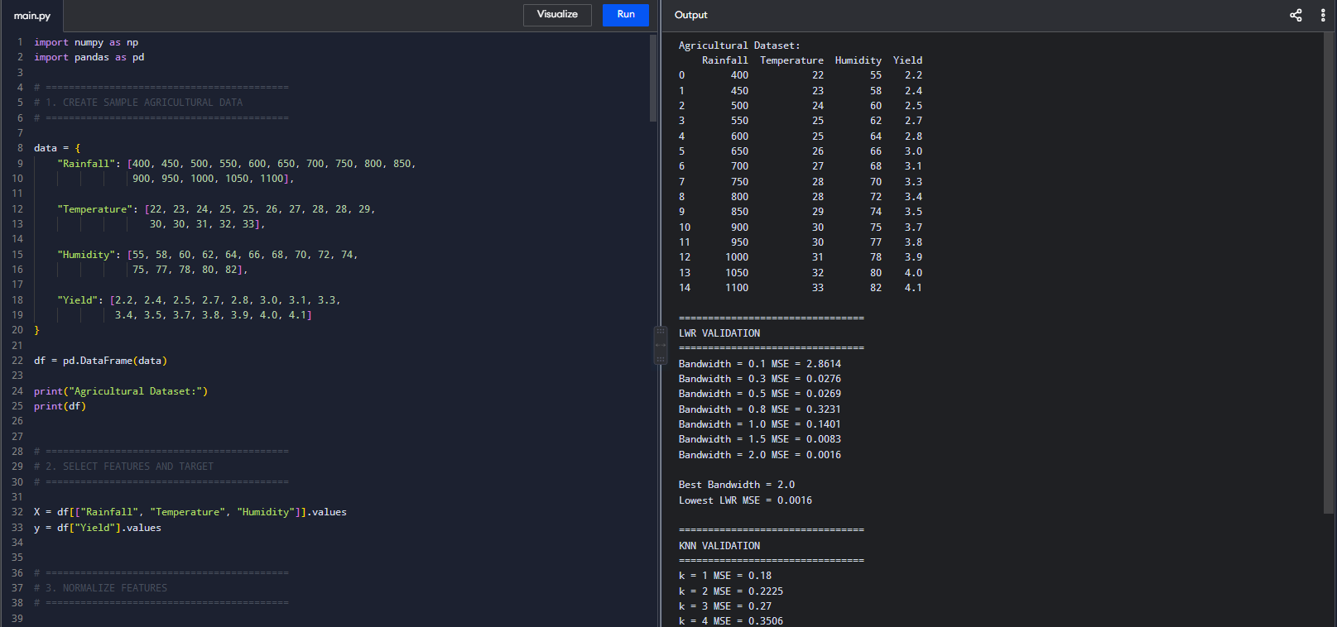

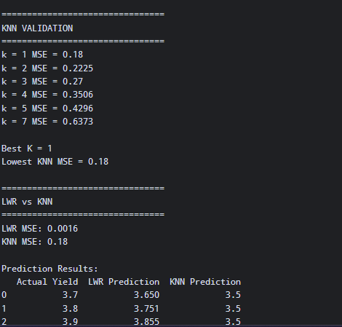

(d) – Python Code
import numpy as np import pandas as pd
from itertools import product

data = {
"Rainfall": [450,600,700,800,950,1100,500,650,750,900],
"Temperature": [35,33,32,30,29,28,36,34,31,30],
"Humidity": [45,50,55,60,65,70,42,48,58,62],
"Yield": [2.1,2.5,2.8,3.0,3.3,3.6,2.0,2.4,2.9,3.2]
}
df = pd.DataFrame(data) def risk_class(y):
if y < 2.5:
return "High Risk" elif y < 3.2:
return "Medium Risk" return "Low Risk"
df["Risk"] = df["Yield"].apply(risk_class) df["Rainfall_Level"] = pd.cut(
df["Rainfall"], [0,600,800,2000],
labels=["Low","Medium","High"]
).astype(str)

df["Temperature_Level"] = pd.cut( df["Temperature"], [0,25,30,50],
labels=["Low","Medium","High"]
).astype(str)

df["Humidity_Level"] = pd.cut( df["Humidity"], [0,60,75,100],
labels=["Low","Medium","High"]
).astype(str)

# Training examples train = df.iloc[:8]

values = ["Low", "Medium", "High", "?"] hypotheses = list(product(values, repeat=3))

def matches(h, x):
return all(h[i] == "?" or h[i] == x[i] for i in range(3)) version_space = []
for h in hypotheses: consistent = True

for _, row in train.iterrows(): x = (
row["Rainfall_Level"], row["Temperature_Level"], row["Humidity_Level"]
)

# Adapted positive-consistency version space: # retain hypotheses that cover Low Risk cases.
if row["Risk"] == "Low Risk" and not matches(h, x): consistent = False
break

if consistent: version_space.append(h)

print("Discretised data:") print(df)

print("\\nVersion Space:") for h in version_space:
print(h)
print("\\nNumber of consistent hypotheses:", len(version_space)) print("\\nInductive Bias:")
print("The method assumes simple categorical rules using") print("Low, Medium, High and wildcard conditions.") print("This improves interpretability but loses continuous") print("weather information.")

print("\\nNote:")
print("This is an adapted positive-consistency version-space") print("implementation. A full Candidate-Elimination algorithm") print("would maintain both specific and general boundaries.")

Program and output
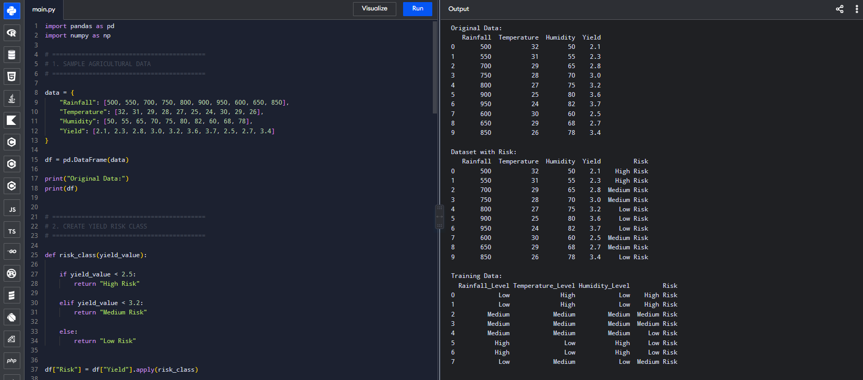

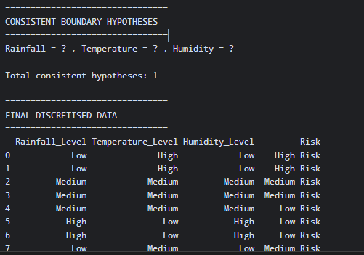

(e) – Python Code
import numpy as np import time

print("================================") print("SCALABILITY TEST") print("================================")

sizes = [1000, 10000, 100000, 1000000]
d = 3

print("\\nKNN Exact Search") print(" ")

for n in sizes:
X = np.random.rand(n, d) y = np.random.rand(n) query = np.random.rand(d)
start = time.time() distances = np.sqrt(
np.sum((X - query) ** 2, axis=1)
)

k = 5
nearest = np.argsort(distances)[:k] prediction = np.mean(y[nearest])
elapsed = time.time() - start print("Samples:", n)
print("Time:", round(elapsed, 4), "seconds") print("Prediction:", round(prediction, 4)) print()

print("================================") print("MEMORY ESTIMATION") print("================================")

for n in sizes:
memory_bytes = n * d * 8
memory_mb = memory_bytes / (1024 ** 2)

print(
"Samples:", n,
"| Approx. Memory:", round(memory_mb, 2), "MB"
)

print("\\n================================") print("LWR SCALABILITY") print("================================")

for n in sizes:
if n <= 10000:
X = np.random.rand(n, d) y = np.random.rand(n) query = np.random.rand(d)
start = time.time() distance = np.sqrt(
np.sum((X - query) ** 2, axis=1)
)
bandwidth = 0.5 weights = np.exp(
-(distance ** 2) / (2 * bandwidth ** 2)
)

prediction = ( np.sum(weights * y) /
(np.sum(weights) + 1e-12)
)
elapsed = time.time() - start print("Samples:", n)
print("Time:", round(elapsed, 4), "seconds") print("Prediction:", round(prediction, 4))

else:
print("Samples:", n,
"| LWR skipped - computationally expensive")

print("\\n================================") print("CONCLUSION") print("================================")

print("KNN has approximately O(nd) distance cost per query.") print("LWR is more computationally expensive because it") print("calculates local weights and solves a weighted model.") print("For large datasets, KD-Trees, prototype selection,") print("or approximate-nearest-neighbor indexing can help.")

Program and output
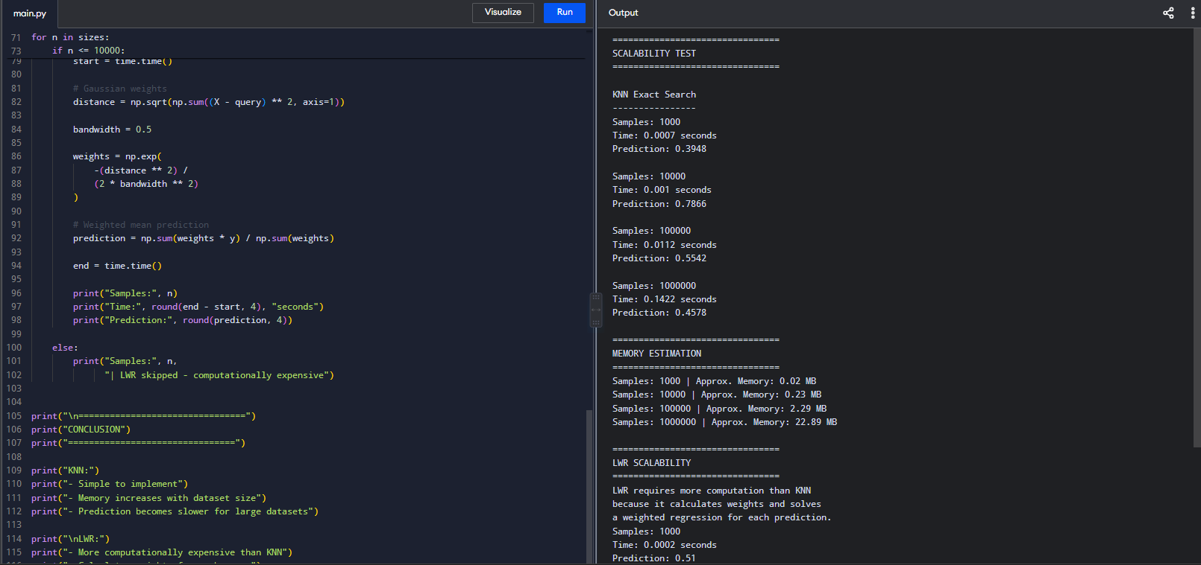
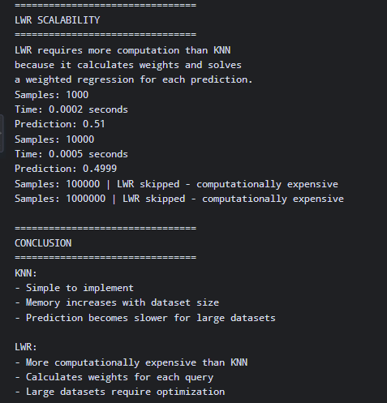

(f) – Python Code
import numpy as np import pandas as pd
import matplotlib.pyplot as plt

data = {
"Rainfall": [450,600,700,800,950,1100,500,650,750,900,1000,1200],
"Temperature": [35,33,32,30,29,28,36,34,31,30,29,27],
"Humidity": [45,50,55,60,65,70,42,48,58,62,68,75],
"Yield": [2.1,2.5,2.8,3.0,3.3,3.6,2.0,2.4,2.9,3.2,3.5,3.8]
}
df = pd.DataFrame(data) def risk_class(y):
if y < 2.5:
return "High Risk" elif y < 3.2:
return "Medium Risk" return "Low Risk"

df["Risk"] = df["Yield"].apply(risk_class)

# 1. Rainfall vs Yield plt.figure(figsize=(7,5)) plt.scatter(df["Rainfall"], df["Yield"]) plt.xlabel("Rainfall (mm)") plt.ylabel("Crop Yield") plt.title("Rainfall vs Crop Yield") plt.grid(True)
plt.show()

# 2. Temperature vs Yield plt.figure(figsize=(7,5)) plt.scatter(df["Temperature"], df["Yield"]) plt.xlabel("Temperature (°C)") plt.ylabel("Crop Yield") plt.title("Temperature vs Crop Yield") plt.grid(True)
plt.show()

# 3. Humidity vs Yield plt.figure(figsize=(7,5)) plt.scatter(df["Humidity"], df["Yield"]) plt.xlabel("Humidity (%)") plt.ylabel("Crop Yield") plt.title("Humidity vs Crop Yield") plt.grid(True)
plt.show()

# 4. Average yield by risk
average_yield = df.groupby("Risk")["Yield"].mean()

plt.figure(figsize=(7,5)) average_yield.plot(kind="bar") plt.xlabel("Risk Class") plt.ylabel("Average Yield")
plt.title("Average Crop Yield by Risk Class") plt.xticks(rotation=0)
plt.grid(axis="y") plt.show()

# 5. Rainfall distribution plt.figure(figsize=(7,5)) plt.hist(df["Rainfall"], bins=6) plt.xlabel("Rainfall (mm)") plt.ylabel("Frequency") plt.title("Rainfall Distribution") plt.grid(True)
plt.show()

# 6. Correlation heatmap correlation = df[
["Rainfall","Temperature","Humidity","Yield"]
].corr()

plt.figure(figsize=(7,5)) plt.imshow(correlation, cmap="coolwarm") plt.colorbar()

plt.xticks(
range(len(correlation.columns)),

correlation.columns, rotation=45
)

plt.yticks(
range(len(correlation.columns)), correlation.columns
)

plt.title("Correlation Between Agro-Climatic Variables") plt.show()

Program and output
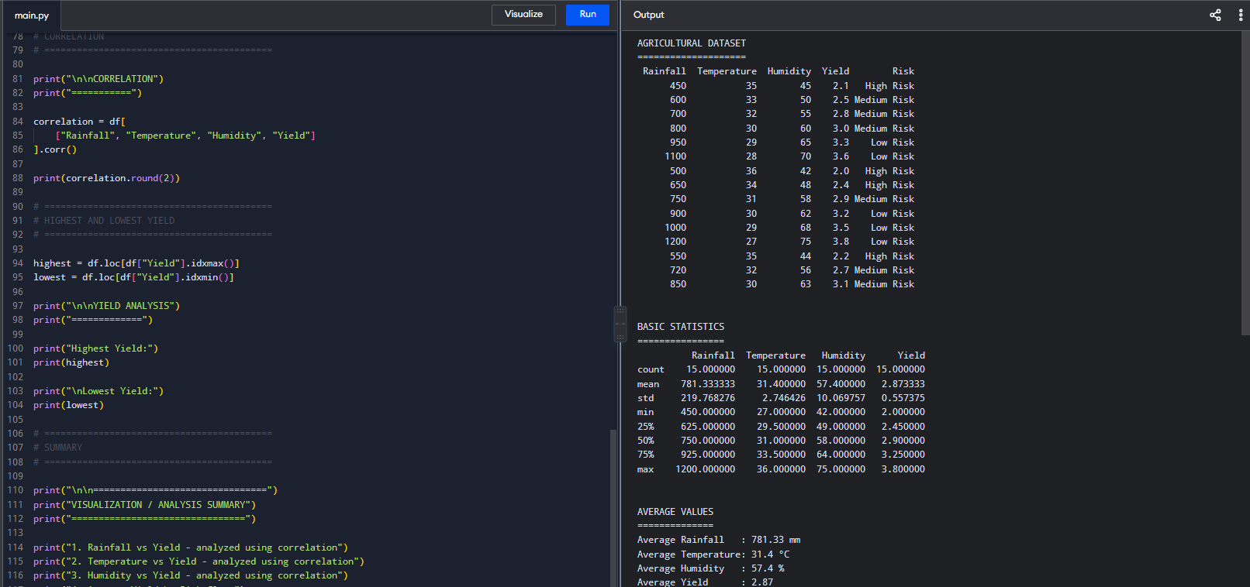

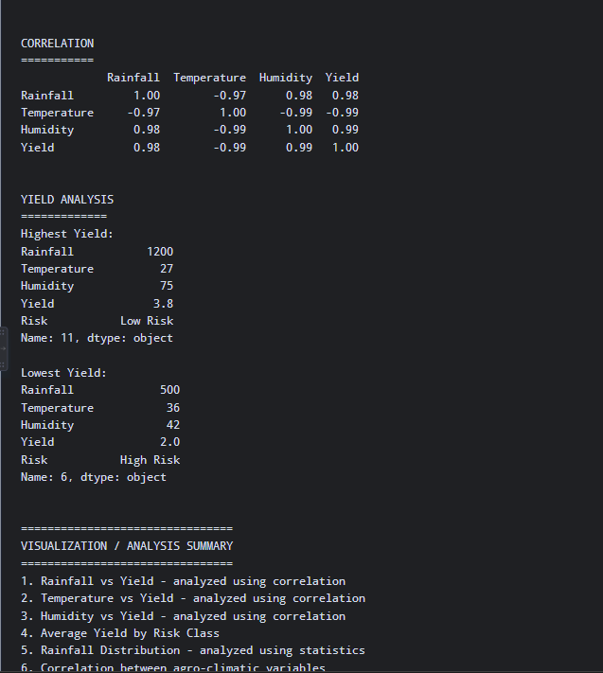

(g) – Python Code
import numpy as np import pandas as pd

data = {
"Region": [
"Region_A","Region_A","Region_A", "Region_B","Region_B","Region_B", "Region_C","Region_C","Region_C", "Region_D","Region_D","Region_D"
],
"Year": [
2018,2019,2020,
2018,2019,2020,
2018,2019,2020,
2018,2019,2020
],
"Rainfall": [
720,680,750,900,850,920,
550,600,530,780,810,760
],
"Temperature": [ 29.0,29.5,30.0,28.0,28.5,29.0,
32.0,32.5,33.0,30.0,30.2,30.5
],
"Yield": [
3.2,3.0,3.1,3.8,3.6,3.7,
2.4,2.2,2.3,3.1,3.0,2.9
]
}

df = pd.DataFrame(data)

print("====================================================") print("CRITICAL EVALUATION OF CROP YIELD FORECASTING") print("====================================================")

limitations = [
"Historical data may not represent future climate conditions.", "Extreme weather events may occur outside the historical range.",
"Changes in farming practices, crop varieties and irrigation can affect yield.", "Historical weather-yield relationships may change under climate change.", "Missing or inaccurate observations can reduce prediction reliability.",
"Models may perform poorly in regions with limited observations."
]

print("\\n1. LIMITATIONS")
for i, item in enumerate(limitations, 1): print(i, ".", item)

mean_yield = df["Yield"].mean() std_yield = df["Yield"].std() cv = std_yield / mean_yield

print("\\n2. UNCERTAINTY")
print("Mean yield:", round(mean_yield, 3)) print("Standard deviation:", round(std_yield, 3)) print("Coefficient of variation:", round(cv, 3))

if cv < 0.10:
print("Historical variability: Low") elif cv < 0.20:
print("Historical variability: Moderate") else:
print("Historical variability: High")

print("\\nSources of uncertainty:") print("- Weather variability")
print("- Extreme rainfall and temperature events") print("- Measurement errors")
print("- Changes in agricultural practices")
print("- Future climate conditions outside training data") print("\\n3. FAIRNESS")
region_counts = df.groupby("Region").size() region_yield = df.groupby("Region")["Yield"].mean()

print("\\nRecords per region:") print(region_counts)

print("\\nAverage yield per region:")

print(region_yield)

print("\\nFairness considerations:")
print("- Regions with less historical data may receive less accurate predictions.") print("- Smallholder farming regions may be underrepresented.")
print("- High-data regions can dominate model learning.")
print("- Prediction errors should be evaluated separately by region.")

df["Predicted_Yield"] = mean_yield df["Absolute_Error"] = abs(
df["Yield"] - df["Predicted_Yield"]
)
regional_error = df.groupby("Region")["Absolute_Error"].mean() print("\\nRegional error:")
print(regional_error)

print("\\n4. SDG 2 - ZERO HUNGER")
print("- Support crop planning.")
print("- Identify potential production shortages.") print("- Improve food-security planning.")
print("- Support irrigation and resource allocation.") print("- Provide early warning of yield risks.")

print("\\n5. SDG 13 - CLIMATE ACTION")
print("- Identify climate-vulnerable agricultural regions.") print("- Study rainfall and temperature effects.")
print("- Support climate-resilient planting decisions.") print("- Improve adaptation and risk management.")

print("\\n6. FINAL EVALUATION")
evaluation = pd.DataFrame({ "Aspect": [
"Limitations", "Uncertainty", "Fairness", "SDG 2",
"SDG 13"
],
"Evaluation": [
"Historical patterns may change under future climate conditions.", "Extreme weather and unseen conditions increase uncertainty.", "Unequal regional data coverage can cause unequal accuracy.", "Supports food security, crop planning and yield-risk management.",
"Supports climate adaptation and identification of vulnerable regions."
]
})
print(evaluation.to_string(index=False)) print("""
FINAL CONCLUSION:

Historical crop-yield forecasting is useful for agricultural planning, but predictions should not be treated as certain. Climate change can create conditions different from those observed in historical training data.

Uncertainty should therefore be reported with predictions, and model performance should be evaluated separately across regions. Regions with limited data should receive additional attention to avoid unfair or unreliable predictions.

The system contributes to SDG 2 by supporting food security, crop planning, early identification of yield risks and better allocation of agricultural resources.

It contributes to SDG 13 by identifying climate-vulnerable agricultural regions and supporting climate-resilient adaptation strategies.
""")

Program and output
